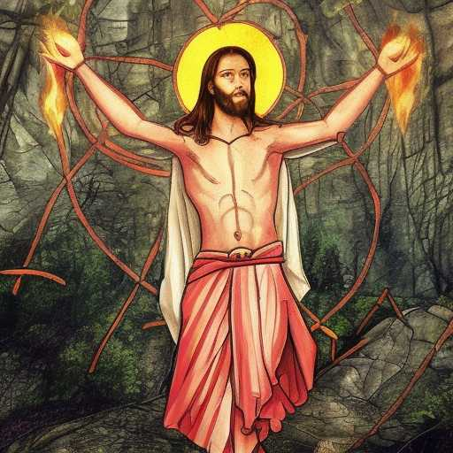
SAVIOR COMPLEX

I was a savior complex, until my superego was crucified
I became a pining hermit and a writer
Or was that me the whole time?
Did She find me first or did I find Her?
What matters that...now?
For She is here
May meek and aming hearts save a world worth inheriting

